TOWN OF LAKE SANTEETLAH
LAND USE PLAN

INTRODUCTION
NCGS 160-383 (d) states, “Zoning regulations shall be designed to promote the public health, safety, and general welfare. To that end, the regulations may address, among other things, the following public purposes; to provide adequate light and air; to prevent the overcrowding of land; to avoid undue concentration of population; to lessen congestion in the streets; to secure safety from fire, panic and dangers; and to facilitate the efficient and adequate provision of transportation, water, sewerage, schools, parks, and other public requirements. The regulations shall be made with reasonable consideration, among other things, as to the character of the district and its peculiar suitability for particular uses, and with a view to conserving the value of buildings, and encouraging the most appropriate use of land throughout such city.”
The Town of Lake Santeetlah (the Town) adopted the current Land Use Plan on ________________ . This Plan, consisting of 38 pages of maps, tables and texts, was developed by a group of property owners working together on the Planning Board. The purpose was to examine existing development and to indicate a desirable arrangement for future land uses. Planning Board members relied heavily upon the desires of the Town’s citizens.
ADOPTION
AND AMENDMENTS
This Land Use Plan was adopted by the Town Council, and, in accordance with the North Carolina law, shall serve as a policy guide for the Town in its future decisions related to land use through its established priorities, goals and plan implementation. This Plan shall be amended upon Town Council’s adoption of amendments to the Town’s land use regulations.
Adopted by the Town of Lake Santeetlah on this the ______ day of _____________________ .

________________________, Mayor

____________________________ , Town Clerk
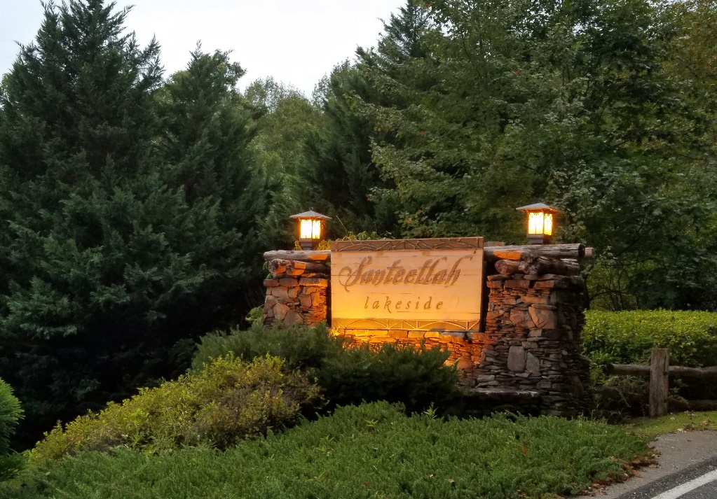

TECHNICAL STUDIES
COMMUNITY INVOLVEMENT INPUT SESSIONS
The Planning Board administered a community wide survey to all property owners on September 30, 2019. The survey instrument was jointly developed by Planning Board members and the Town Attorney, along with input from NC Commerce.
The survey asked for input in the following areas: population characteristics, the Town’s Vision, Land Use and Community Character, and Municipal Services. The survey instrument also asked for narrative responses to the following: The Town’s Greatest Strengths, The Town’s Greatest Weaknesses, The Biggest Issue Facing the Town over the next 20 years and The Town Vision 20 Years from Now. The Survey Results Document (Attachment 1) contains response data from the Survey. The Survey instrument, along with tabulated response data, can be found in Attachments 2 and 3. Census data is found in Attachment 4. The response tabulation process is found in Attachment 5. The Zoning Map is contained in Attachment 6.
The Town received 103 completed responses out of 196 survey mailers. This represents a response rate of approximately 53%. The Planning Board compiled the results and produced the Survey Results Document which was the basis for the Land Use Plan.
A Public Hearing on the Survey Results Document and the draft Land Use Plan was held on March 12, 2020.

CURRENT AND COMPARATIVE
DEMOGRAPHICS
The important findings and trends that were identified
in the research, study and analysis of current
demographics are presented below. Please see the attachments
for the full findings concerning the demographics study
undertaken.

CURRENT POPULATION, SOCIAL, AND ECONOMIC CHARACTERISTICS AND TRENDS

The Planning Board studied the population characteristics obtained from the 2000 US Census, the US Census Bureau 2013 – 2017 American Community Survey 5-Year Estimates for income, 2018 Population Estimates (Attachment 4). Takeaways are:
The largest segment of the Town’s population is of retirement age.
The Town of Lake Santeetlah enjoys the lowest level of poverty (3.8%).
Median housing value is $567,300.
Median income per household is $56,563.

Tabulation of survey responses show:

The majority of property owners are non-resident.
Most have owned property 11 to 20 years and 21 years and over.
Most spend five (5) months or less in the Town.
The majority of owners do not plan to make the Town their primary place of residence within the next five (5) years.

GEOGRAPHIC CHARACTERISTICS
PHYSICAL FEATURES
Land Area: 128 acres = .2 sq miles
Real Property Value $83,346,400 INFRASTRUCTURE
Eight (8) Buildings + One (1) public Building with Town Services
4.78 miles of Town streets
.5 acres of Town parks
5.28 miles of Town waterlines
196 Town water meters
30 Town fire hydrants

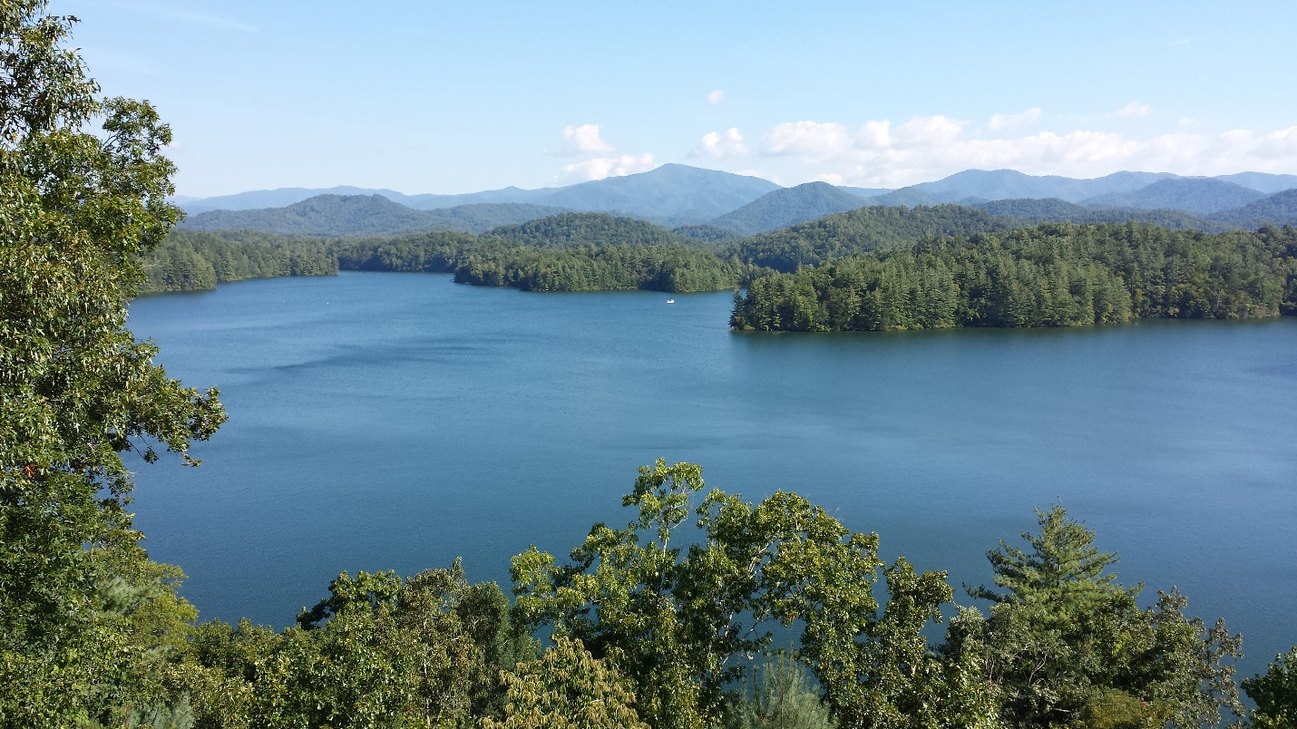

The Town’s current land area is 128 acres which is approximately .2 square miles and bordered largely by the US Forest Service owned land. The Town is built along Lake Santeetlah, a 2,881 acre lake and maintained by Brookfield, an entity outside the Town’s purview. The Lake has been recently acclaimed to be the cleanest and most beautiful in the country. The Town is considered as a recreational area with the natural beauty of the lake and surrounding woodlands. The majority of homes are located on steep terrain that borders the lake area. Most of the properties are used for vacation purposes or are rented for vacation purposes by the homeowners. The Town has a relaxed and serene atmosphere. Properties are built to take in the natural beauty of the area. The community does not want to see this changed.
COMMUNITY INFORMATION
AND INPUT SESSIONS

The Town held a Public Hearing (Hearing) on the Land Use Plan on March 12, 2020 at Town Hall. Both the Land Use Plan and the Survey Results Document were made available for review on the TOLS website prior to the Hearing. Property owners were advised of the website documents via mass email. The Hearing was widely advertised by Town Council, the Planning Board and Town Hall Staff, with a notice of the Hearing place, date and time placed in the local newspaper. Zoom was available for use for property owners who were not in residence at the time of the Hearing. Property owners were provided the call-in number and code.
This meeting provided a good opportunity to inform the Town’s citizens about their collective input regarding land use and other related matters and to receive their input.

Public comments were as follows:
- Detailed answers from the survey do not mention the Town Council as a weakness for the Town. (See Biggest Issues Chart in this Plan and in the Survey Results Document along with the Greatest Weaknesses Chart in Survey Results Document).
- The Town Map is incorrect. (See Review of Zoning Map section contained in this document.)
- How were percentages included in the reporting and which comments were considered in the response tabulation. (See Response Tabulation Methodology in Attachment 5.)
- Does the Town want Zoning. (See Land Use Plan Section on “Town of Lake Santeetlah Vision”, narrative results showing “Some growth with enforced zoning – No Multi Family” as number two (2) in most frequent responses).
- The Survey has “pushy” questions and was composed in a manner to retrieve specific answers. (The Survey was reviewed by the TOLS Town Attorney and NC Commerce; all recommended revisions were incorporated.)
- In response to the number of current home setbacks, the Planning Board measured 100% of homes and found only 22% to be out of compliance. Most of the con-compliant homes were built before the Town was established.
Town Attorney Craig Justus explained that, according to Senate Bill 355, the terminology, Comprehensive Plan, should be changed to Land Use Plan. This revision is incorporated.

TOWN OF LAKE SANTEETLAH VISION
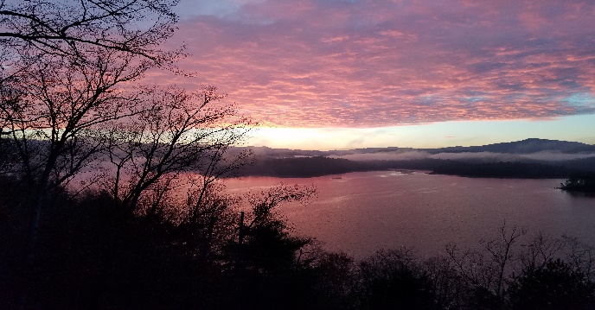
Lake Santeetlah is the focal point of the community. The majority of property owners agree that the Town should remain as unchanged as possible over the next 20 years and with minimal disturbance to the land. New development should be in accordance with the Town’s “mountain view” character. The Community’s most frequent responses to the narrative questions regarding “The Town’s Vision 20 Years from Now” were:
- Remain Without Change
- Some Growth with enforced zoning- no Multi-Family
- Remain the same with more community spirit

Responses to the Survey’s questions on specific issues reflect that the community wants minimum disturbance of land and the addressing of public nuisances and residents’ safety and welfare. Property values should be conserved and only single-family homes encouraged. Refer to Survey Results Document, Attachment 1.

STATED GOALS:
MAINTAIN THE MOUNTAIN VIEW CHARACTER
REMAIN AS UNCHANGED AS POSSIBLE
MINIMAL DISTURBANCE OF LAND
ADDRESS PUBLIC NUISANCES
CONSERVE PROPERTY VALUES
LAND USE AND COMMUNITY CHARACTER

As the homes are located on Lake Santeetlah, residents purchased their properties for the enjoyment of the Lake itself and the surrounding natural beauty of the forests. The US Forest Service owns the woodlands across from the homes, thereby eliminating residential or commercial development from the residents’ lake view.
It is the consensus of residents that the Town’s lakeside and lakeview homes should remain free from any and all future renovation of current homes that would limit the lakeside views of current properties. Residents favor maintaining and improving the current infrastructure. Light and noise pollution along with signage should be addressed. Tourism should be discouraged and regulations for vacation rentals are needed. Natural resources should be protected. Survey results are found in the Survey Results Document, Attachment 1.

STATED GOALS:
MAINTAIN LAKESIDE VIEWS FOR PROPERTY OWNERS
FUTURE RENNOVATION SHOULD NOT LIMIT VIEWS
MAINTAIN AND IMPROVE CURRENT INFRASTRUCTURE
ADDRESS LIGHT AND NOISE POLLUTION AND SIGNAGE
PROTECT NATURAL RESOURCES
VACATION RENTAL REGULATIONS

MUNICIPAL SERVICES

SEWER
The Town has no public sewer system. The homes are served with septic tanks. Since many homes are up to 30 years old, the Town is actively researching the costs of a sewer system. The Town Council previously sent to property owners a separate survey to gain their input for a system.
The Land Use Survey instrument showed that approximately half of property owners favor no change in sewers. However, narrative results reflect the sewer system/failing septic tanks is one of the top three biggest issue facing the Town.

WATER

The Town is comprised of 196 water connections. The Town’s water system is 30 years old. The system consists of four (4) well houses, a filter house, and two (2) pump houses.
The 125,000 gallon capacity water tank is currently in need of painting, both inside and out. The other houses require paint as well. Total cost for the repairs is estimated at $250,000. To date, two pump house holding tanks have been painted with one to go. The well houses have been repaired.
During the last few years the Town has experienced multiple water breaks that resulted in costly repairs. This is a result of improper installation of water lines 30 years ago. The Town has applied for a grant for GIS mapping of the water lines.
Survey results show that property owners favor no change in the water system. However, narrative responses to the Top Three Biggest Issues Facing the Town show infrastructure maintenance and sewer system/failing septic as being the top three issues of concern. See Single Biggest Issue Chart in section below.
The Community favors no change in police and fire protection, erosion control, garbage and EMS services and street maintenance.

STATED GOALS:
PURSUE FURTHER INPUT INTO INFRASTRUCTURE
MAINTAIN CURRENT POLICIES FOR PUBLIC SERVICES

SINGLE BIGGEST ISSUE FACING THE TOWN OVER THE NEXT SEVERAL YEARS

The Community identified the following:

- Litigation/Dissidents
- Infrastructure Maintenance
- Sewer System/Failing Septic

REVIEW OF ZONING MAP

As a part of the Land Use Plan, the Town’s Zoning Map (the Map) was reviewed in order to determine general consistency of uses present and uses allowed on an individual parcel basis. A copy of the Town’s current Map is found in Attachment 6. This is a compressed copy and is not to scale. The actual Map is available for view at Town Hall.
Town Hall Staff reviewed previous discussions and decisions regarding the Map. The Official Zoning Map currently in use is dated November 17, 2015 and has no subsequent revisions. Staff have determined the current Map to be accurate.
The Planning Board is recommending no change to the Map at this time.

ATTACHMENTS

ATTACHMENT 1: SURVEY RESULTS DOCUMENT

ATTACHMENT 2: SURVEY INSTRUMENT

ATTACHMENT 3: TOTAL RESPONSE TABULATION BY CATEGORY (NOTE: SOME CATEGORIES REFLECT RESPONSES IN TWO COLUMNS, E.G. “AGREE” AND STRONGLY AGREE” OR “DISAGREE AND STRONGLY DISAGREE”

ATTACHMENT 4: US CENSUS DEMOGRAPHIC DATA

ATTACHMENT 5: RESPONSE TABULATION METHODOLOGY

ATTACHMENT 6: ZONING MAP

ADDENDUM

Planning Board Members:
Kim Matheson, Town Administrator
Emily Hooper, Town Clerk
Anne Hager, Chair
Bill Piel
OH Yarberry
Beth Carlton
Tanya Capeling
Craig Keith (former member)
Dr. Bill Campbell (former member)

Town Council Members:
Jim Hager, Mayor and Finance Officer
Keith Predmore, Vice Mayor
Roger Carlton
Craig Keith
Diana Simon

Town Attorney:
Craig Justus

